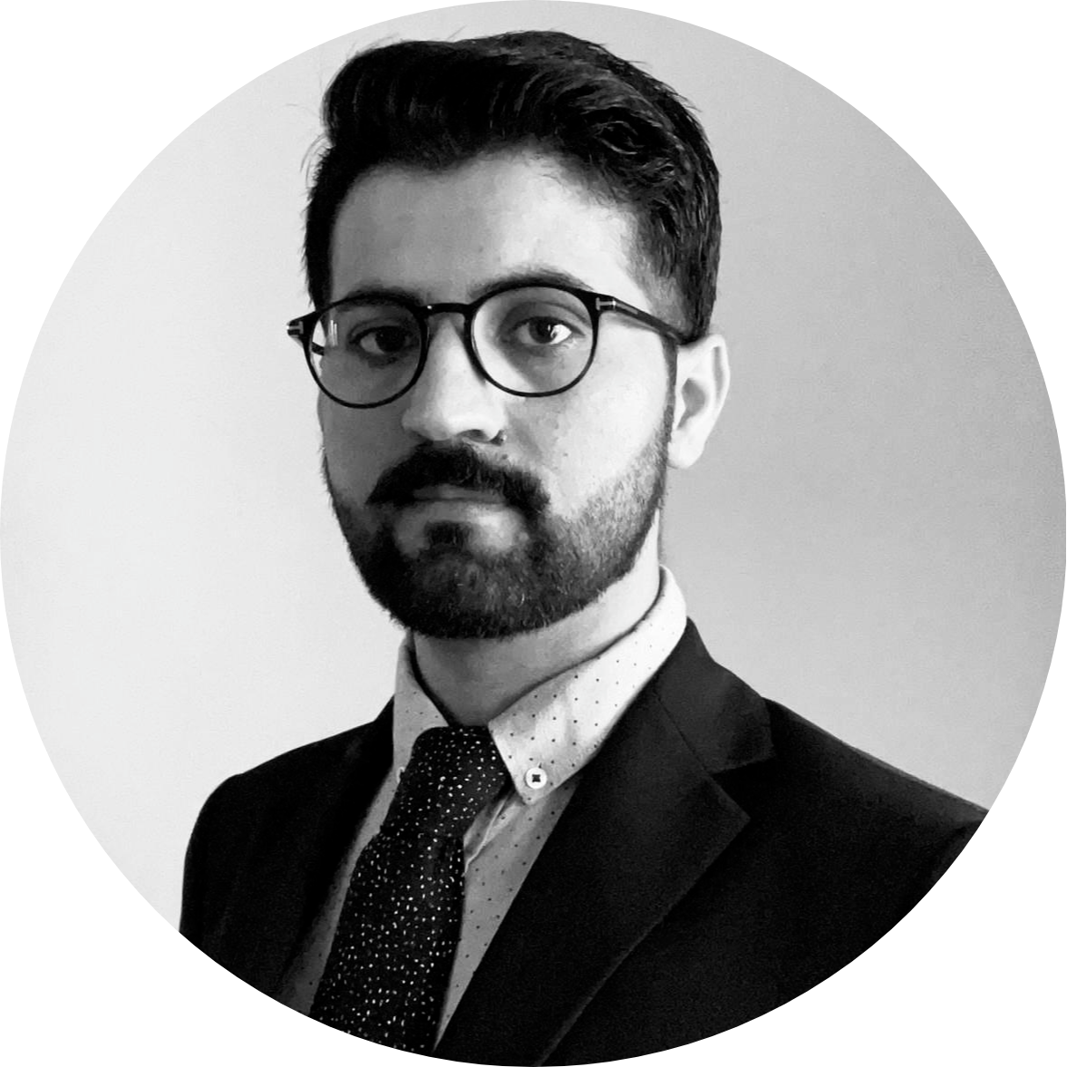**SAFDAR AQEEL SAFDAR**

**Address: Kalbakkveien 13A, 0953, Oslo, Norway**

**Date of Birth: 02/02/1992**

**Mobile#: +47 902 15 339**

**Email:** [**safdar.aqeel@dnb.no**](mailto:safdar.aqeel@dnb.no)

**...** [**safderaqeel@yahoo.com**](mailto:safderaqeel@yahoo.com)

**Summary**

An enthusiastic computer scientist and practitioner with excellent academic records and 8 years of experience working on multiple R&D projects that span the area of software modeling, testing, search algorithms, and machine learning at various known research institutes. I am a results-driven, customer-focused, articulate and analytical software engineer/architect who is skilled in software design & development, IT architecture, and cloud infrastructure.

**Education**

* **IT Architect (Designed for industry professionals) (2018 – 2021)**
* University of Oslo, Oslo, Norway
* DNB Bank ASA
* **Ph.D. in Software Engineering/Computer Science (2015 – 2020)**
* University of Oslo, Oslo, Norway
* **MS in Computer Science (2013 – 2015)**
* National University of Computer & Emerging Sciences (FAST-NU), Islamabad, Pakistan
* GPA 3.8/4.0
* **BS in Computer Science (2009 – 2013)**
* National University of Computer & Emerging Sciences (FAST-NU), Islamabad, Pakistan
* GPA 3.1/4.0

**Work Experience**

* **IT Architect & Software Engineer at DNB Bank ASA (Currently)**

I have been working as an IT Architect/Software Engineer from August 2018 up till now at DNB Bank, Oslo, Norway. As a part of my job, I worked with a wide range of tasks in different projects such as designing and developing APIs and event hub platform, CI/CD, AWS cloud infrastructure, and developing solution architectures for various products in addition to working with new technologies such as Kubernetes, Kafka, cloud services. Moreover, I also get to participate in enterprise level activities such developing IT strategy for DNB.

* **Ph.D. Research Fellow at Simula Research Laboratory (July 2015-June 2018)**

I worked as a Ph.D. Research Fellow from July 2015 up till June 2018 at Simula Research Laboratory, Oslo, Norway. The object of my Ph.D. thesis was to improve the post-deployment configuration experience for Cyber-Physical System Product Lines. More specifically, capturing the patterns of configurations in form of configurations rules and making configuration recommendation for interacting products using machine learning and multi-objective search algorithms. I also participated in research activities such as paper reviews, discussions, and reviews for international conferences and journals.

* **Research Fellow at QUEST Lab, Pakistan (June 2013-June 2015)**

I worked as Research Fellow from June 2013 to June 2015 at QUEST lab, Islamabad, Pakistan. During this tenure, I worked on industrial problems with the collaboration of other senior researchers. I planned and conducted controlled experiments and wrote a number of research papers. I also participated in research activities such as paper reviews, experiments, discussions, and peer reviews.

* **Public Relation Officer at Sublime Pakistan (Jan 2012-May 2013)**

I worked as Public Relation Officer at Sublime Pakistan (An event management company) where my responsibility was to interact with the public. We organized a number of formal and informal events in different cities of Pakistan.

**Technical Skills**

|  |  |  |
| --- | --- | --- |
| **Skills/Proficiency** | **Proficient** | **Prior Experience** |
| **Programming Languages** | Java | Python, R, C#,C++, PHP |
| **Cloud, infrastructure services, and tools** | AWS cloud services, CI/CD, Kafka, Kubernetes |  |
| **Programming Tools** | IntelliJ | Eclipse, PyCharm, R-Studio, MS Visual Studio, Dreamviewer |
| **Modeling Languages** | UML and UML Profiles,Feature Model | CVL, BVR |
| **Modeling Tools** | IBM RSA, MagicDraw, Papyrus, Enterprise Architect, Pure::Variants, fmp | CVL tool, BVR tool |
| **Testing Tools** | Junit, Nunit, Selenium, Sikuli, RBF |  |
| **Machine Learning and Statistics Tools** | Weka, R-Studio, IBM SPSS |  |

**Notable Industrial Projects**

* *Event Hub Platform:* In this project, I worked as solution architect/software engineer to design and develop an event hub. More specifically, we used MSK (AWS managed service for Kafka) and combined with various components from Confluent (e.g., schema registry and rest proxy) in addition to building our own components to build a platform which can be used by multiple teams to product and consume events within the organization.
* *Personal Finance Management (PFM):* In this project, I worked as a solution architect and helped the team to conduct a POC using an insight engine by Personnetics and AWS services in addition to designing the target solution.
* *New Payment Engine:* In this project, I worked as infrastructure/software engineer, where I worked on setting up and managing AWS accounts, Jenkins, Bitbucket, and so on. Besides that I also worked on development and testing tasks to build and test APIs.

**Research Interests and Expertise**

|  |  |  |
| --- | --- | --- |
| * Machine Learning | * Search-based Software Engineering | * Empirical Software Engineering |
| * Model-based Testing | * Product Line Engineering | * Model-driven Software Engineering |

**Research Projects**

* *Post-Deployment Configuration Recommendation:* In this project, we proposed a multi-objective search-based technique that recommends the configurations for a system of systems to ensure the correct behavior of the system using software constraints. The proposed approach is published in a journal paper [TOSEM-2021](https://dl.acm.org/journal/tosem).
* *Facilitating Automated Configuration of CPS Product Lines:* In this project, we proposed a conceptual framework to support the automated configuration of CPS product lines, which involves variability modeling, constraint specifications, and different automated functionalities of a configuration tool. The proposed framework is published in a journal paper [SoSym-2020](https://link.springer.com/article/10.1007/s10270-020-00803-8).
* *Mining Cross Product Line Rules:* In this project, we proposed a technique, which combines machine learning and multi-objective search algorithms to mine the rules specifying the abnormal behavior of system. The results are published in one conference paper at [GECCO-2017](http://dl.acm.org/citation.cfm?id=3071261) and a journal paper in [ASE-J-2019](https://link.springer.com/content/pdf/10.1007/s10515-019-00266-2.pdf).
* *Variability Modeling for Cyber-Physical Systems (CPSs):* In this project, we proposed a set of variation points and modeling requirements to capture the variabilities of *CPS* product lines. Further, we evaluated four existing variability modeling techniques based on framework. Results of this project are published in a conference publication at [SAM-2016](https://link.springer.com/chapter/10.1007/978-3-319-46613-2_1).
* *Evaluating UML Modeling Tools:* In this project, we evaluated the capabilities of UML modeling tools in terms of modeler’s productivity using controlled experiment. Evaluation results are published in a conference publication at [ECMFA-2015](https://link.springer.com/chapter/10.1007/978-3-319-21151-0_3).

**Publications/Research Work**

* Improving Post-Deployment Configuration of Cyber-Physical Systems Using Machine Learning and Multi-Objective Search (Ph.D. Thesis), **Safdar Aqeel Safdar**, Published by University of Oslo, Norway, 2021
* Recommending Faulty Configurations for Interacting Systems Under Test Using Multi-Objective Search, **Safdar Aqeel Safdar**, Tao Yue, Shaukat Ali, Accepted to ACM Transactions on Software Engineering and Methodology (TOSEM) 2021
* Quality Indicators in Search-based Software Engineering: An Empirical Evaluation, Shaukat Ali, Polo Arcaini, Dipesh Pradhan, **Safdar Aqeel Safdar**, Tao Yue, Published in ACM Transactions on Software Engineering and Methodology (TOSEM) 2020
* A Framework for Automated Multi-Stage and Multi-Step Product Configuration of Cyber-Physical Systems, **Safdar Aqeel Safdar**, Hong Lu, Tao Yue, Shaukat Ali, Kunming Nie, Published in the International Journal of Software and Systems Modeling (SoSym), 2020
* Using multi-objective search and machine learning to infer rules constraining product, **Safdar Aqeel Safdar**, Hong Lu, Tao Yue, Shaukat Ali, Published in the International Journal of Automated Software Engineering (ASE), 2019
* Mining Cross Product Line Rules with Multi-Objective Search and Machine Learning, **Safdar Aqeel Safdar**, Hong Lu, Tao Yue, Shaukat Ali, published in Genetic and Evolutionary Computation Conference, GECCO, 2017.
* Evaluating Variability Modeling Techniques for Supporting Cyber-Physical System Product Line Engineering, **Safdar Aqeel Safdar**, Tao Yue, Shaukat Ali, Hong Lu published in System Analysis and Modeling Conference, SAM, 2016.
* An Empirical Evaluation of UML Modeling Tool- An Experiment, **Safdar Aqeel Safdar**, Muhammad Zohaib Iqbal, Muhammad Uzair Khan published in European Conference on Modeling Foundations and Applications, 2015
* A Comparative Study of UML Modeling Tools (MS Thesis), **Safdar Aqeel Safdar**, 2015

**Academic Services**

* Reviewed papers for several well reputed international journals and conferences including as a reviewer and sub-reviewer.

**Activities, Honors, and Awards**

* Very High Distinction (Silver Medalist, second highest) in MS degree
* BS degree partially (50%) funded by Punjab Educational Endowment Fund (PEEF) Scholarship
* MS degree fully funded by ICT R&D, Pakistan
* Regarded as a high achiever in the university magazine (2015)
* Student volunteer in an international conference (ICET 2014)
* Volunteer in Software Tester Meetup at FAST-NU (2014)
* Participated in a technical event (NASCON-2013) as IT head at FAST-NU
* Conducted several workshops of basic-level Asp.Net and PHP at FAST-NU

**Personal Skills**

|  |  |  |
| --- | --- | --- |
| * Good Communication Skills | * Problem Solving | * Entrepreneurial Skills |
| * Quick Learner | * Team Player | * Leadership |

**Languages**

|  |  |  |
| --- | --- | --- |
| * English (Proficient) | * Norwegian (A2) | * Urdu (Mother Tongue) |

**References**

References will be provided if required.